**Datascience task 2**

Blog link is [here](https://algorithammer.herokuapp.com/)

Keyword density pic is here:

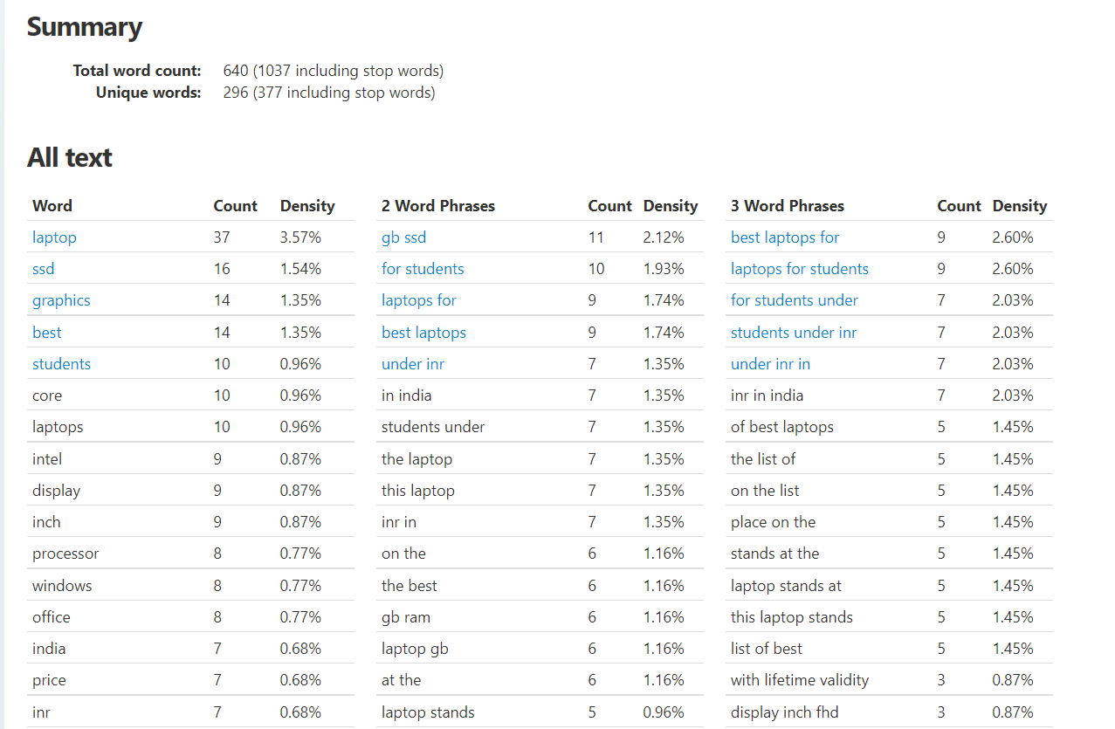

You dont have to do the frontend, with your datascience skills, you need to give accurate results

In the form of 3 separate lists in one list (nested lists)

[

0 : [],

1:[],

2:[],

]

And each nested list must have word, word count, density

For oth list, as you can see the above output

0th list must have one word

1st list must have 2 word

2nd list must have 3 word

The output must be very accurate

Submit github link

And video link showing the same blog description as input and this as output (output format is mentioned above)